http://www.umanitoba.ca/outreach/cm/vol10/no19/therabbits.html

The Rabbits – John Marsden, illustrated by Shaun Tan
February 12, 2010 ~ Polly
I “met” Shaun Tan in the Byward Market in Ottawa when I was waiting for someone at the bookstore, and developed a serious crush on The Arrival, a story about immigration told entirely in pencil drawings. Then I learned about The Rabbits. And Tales of Lost Suburbia. And all of his other books, each more amazing than the last. In fact, I co-own all of them, thanks to a gift of a “complete set”. The set is “complete” until more books are published, and then I will just have to go out and re-complete it.
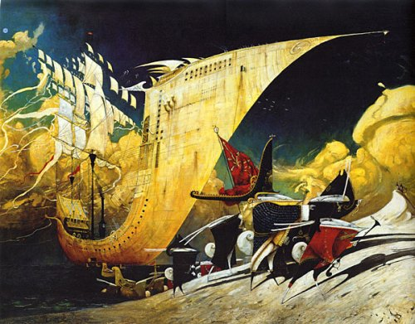
The Rabbits is a book about colonialism and its attendant evils (particularly environmental and cultural destruction), carried out with vigour and innocence by The Rabbits, who land in Australia and proceed to overrun it. Ecological history and human history meld. You could say that it’s an obvious metaphor, or you could say that it’s a brilliant parallel. I say “brilliant”.
Marsden uses words sparingly, and with effect. The sentences are clean and simple – there is dignity in them and a quiet despair. Tan, on the other hand, does not hold back with his illustrations. Sometimes simple, sometimes filled with activity, each one covers both pages. They are large, they are art, and in their colour and content they convey the various moods of Marsden’s text.
Tan has a gift for using unusual shapes to convey strangeness or making the strange seem almost natural (he also does this in The Arrival). The Rabbits look so…strangely familiarly Victorian (perhaps only familiar to colonials?)…with their machines, their high collars, their wig-like ears, their monocles and perambulators, their dark suits and long dresses, their hugs chests and tiny feet. Their Australian counterparts seem more real. Less strange. The world of pre-Rabbit Australia is serene and natural; post-Rabbit Australia is a contorted cacophony.
I’m not going to lie: it’s a scary book. It ends with tough questions, none of which have answers (ex. Who will save us from the Rabbits?). So if you like to know the answers, this may not be the book for you. But it is a book for me, and I’m glad to have it…especially so as it is extremely difficult to get your hands on it in North America and it more or less had to be special-ordered through Australia (or something ridiculous like that). I don’t know for sure, I just know that of the “complete set”, this book was delivered nearly a month after all of the others had arrived. It was well worth the wait.
I think The Rabbits is appropriate for people of many ages because although there aren’t many words, this book generates a lot of thought and questions, and older readers might have a better understanding of “Rabbits aren’t actually scary and bad, they are just a symbol.” The illustrations also use techniques (simplicity, complexity, organization of shapes and – unless I am mistaken – are done in different media) that could be appreciated by a budding artist, and the book has a message that people of all ages can appreciate. It is one of my favourite Shaun Tan books.
Favourite Line: At first we didn’t know what to think. They looked a bit like us. There weren’t many of them. Some were friendly.
Reading Ages: 5 and up.
Rating: A
https://vickyandpolly.wordpress.com/2010/02/12/the-rabbits-john-marsden-illustrated-by-shaun-tan/

